## 1. Orchestration Tools: Managing and Scaling Application Servers

### (a) How do these tools help manage and scale application servers?

Orchestration tools like Kubernetes provide a system to automate the deployment, scaling, and management of containerized applications. These tools help to manage application servers by distributing workloads across a cluster of machines, ensuring high availability, fault tolerance, and resource optimization. Kubernetes dynamically allocates resources to containers based on demand, scaling the applications up or down based on predefined rules or system load.

### (b) How do orchestration tools facilitate automated deployment, scaling, and management of application servers?

Orchestration tools such as Kubernetes automate the deployment of applications using configurations like YAML files. They can monitor the health of applications, automatically replace failed containers, and scale applications up or down based on metrics like CPU usage, memory usage, or custom conditions. This eliminates the need for manual intervention and helps maintain a stable and resilient application environment.

## 2. Difference Between Pod, Deployment, and Service

**Pod:** A Pod is the smallest and simplest Kubernetes object, representing a single instance of a running process in a cluster. It can contain one or more containers that share the same network namespace and storage.

**Deployment:** A Deployment is a higher-level abstraction that manages a set of identical Pods. It ensures that the specified number of Pods are running, and handles updates and rollbacks.

**Service:** A Service is an abstraction that defines a policy to access Pods. It ensures that network access to the Pods is consistent, even as the Pods are created, deleted, or scaled up/down.

## 3. What is a Namespace in Kubernetes? Provide an example.

A Namespace in Kubernetes is a way to partition cluster resources and provide a scope for names. It allows multiple users or teams to share the same cluster without interfering with each other. Each Namespace provides a set of resources such as Pods, Services, and Deployments, isolated from other namespaces.

**Example:** A common example would be a "development" namespace for development resources and a "production" namespace for production resources. These namespaces allow users to isolate workloads and apply different policies.

## 4. Role of the Kubelet and Checking Nodes in a Kubernetes Cluster

The **Kubelet** is an agent that runs on each node in a Kubernetes cluster. It ensures that the containers described in the PodSpecs are running and healthy. The Kubelet monitors the containers and manages their lifecycle, making sure that the desired state is maintained.

To check the nodes in a Kubernetes cluster, you can use the following command:

kubectl get nodes

## 5. Difference Between ClusterIP, NodePort, and LoadBalancer Services

**ClusterIP:** Exposes the service on a cluster-internal IP address. This means it is only reachable from within the Kubernetes cluster.

**NodePort:** Exposes the service on a specific port on each node in the cluster. This makes the service accessible from outside the cluster using the node's IP address and the specified port.

**LoadBalancer:** Exposes the service externally using a cloud provider's load balancer. This service type provisions an external IP address and balances traffic across the nodes in the cluster.

## 6. Scaling a Deployment to 5 Replicas

To scale a Deployment to 5 replicas using kubectl, you can use the following command:

kubectl scale deployment --replicas=5

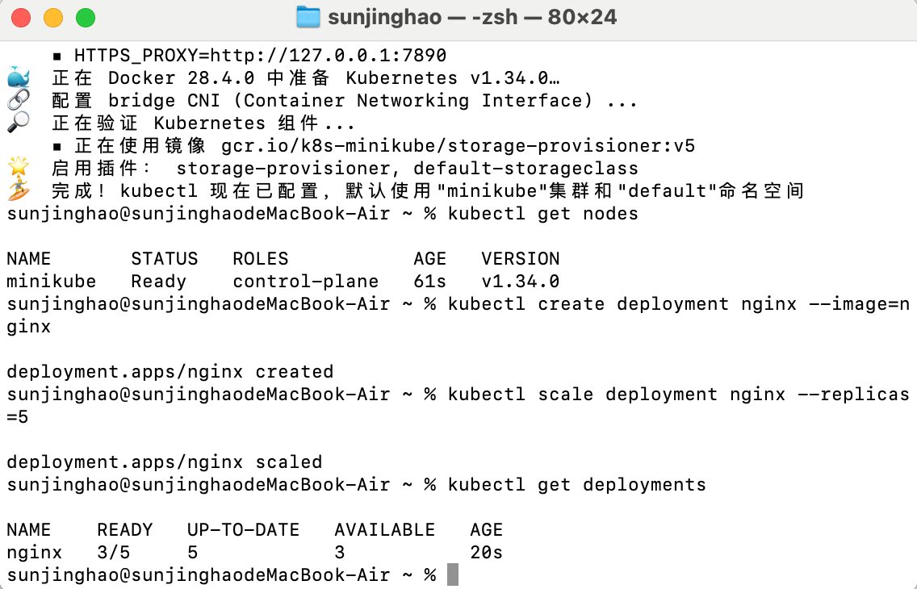

## 7. Updating the Image of a Deployment Without Downtime

To update the image of a Deployment without downtime, you can use the rolling update strategy. Kubernetes will gradually replace the old Pods with new ones to ensure that the application remains available throughout the process. You can do this with the following command:

kubectl set image deployment/ =:

This will trigger the rolling update process.

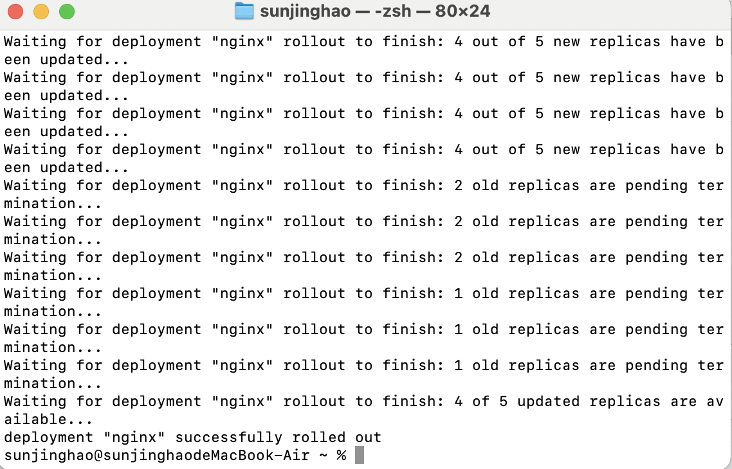

## 8. Exposing a Deployment to External Traffic

To expose a Deployment to external traffic, you can create a Service of type **LoadBalancer** or **NodePort**. For example, to expose a Deployment using a LoadBalancer, you can use the following command:

kubectl expose deployment --type=LoadBalancer --port=80 --target-port=8080

This will create a LoadBalancer service and expose the deployment externally.

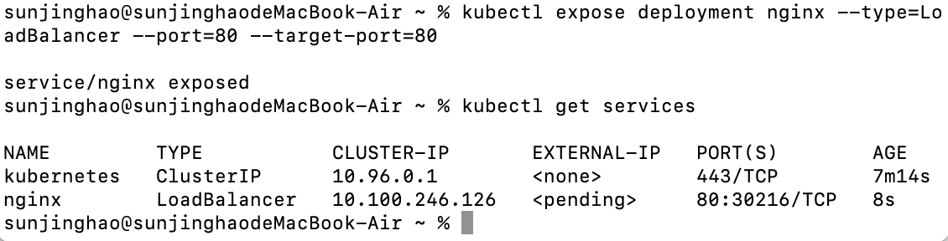

## 9. How Kubernetes Scheduling Decides Which Node a Pod Runs On

Kubernetes uses a scheduler to determine where Pods are placed in the cluster. The scheduler considers factors like node resource availability (CPU, memory), affinity and anti-affinity rules, taints and tolerations, and other policies to decide which node a Pod should run on. The goal is to optimize resource utilization and maintain high availability and reliability.

## 10. Role of Ingress and Difference from a Service

**Ingress:** In Kubernetes, Ingress is a resource that manages external access to services within the cluster, typically HTTP/HTTPS traffic. It provides routing based on URL paths, hostnames, and other HTTP-based rules. Ingress controllers are responsible for managing and implementing the ingress rules.

**Service:** A Service is used to expose a set of Pods as a network service, allowing Pods to communicate with each other and external resources. While a Service is used for exposing the internal application, Ingress manages external HTTP/HTTPS traffic routing to services within the cluster.